What is Angular Router?
Angular Router enables navigation between different views (components) in a Single Page Application (SPA) without reloading the page.
It maps URL paths → Components.
Example:
- /home → HomeComponent
- /about → AboutComponent
- /contact → ContactComponent

Router Setup Steps
- Create components
- Define routes
- Configure router
- Add router outlet
- Add navigation links

Route Guards
What are Route Guards?
Route Guards control access to routes.
Example use cases:
- Login required pages
- Admin pages
- Prevent leaving form page
Types:
- CanActivate
- CanDeactivate
- CanLoad
- CanMatch

Routing and Navigation
Navigation Types
1.Template Navigation
Using RouterLink
<a routerLink="/home">Home</a>
2.Programmatic Navigation
Using Router Service
import { Router } from '@angular/router';
constructor(private router: Router) {}
this.router.navigate(['/home']);

What is RxJS?
RxJS (Reactive Extensions for JavaScript) is a library for reactive programming using streams of asynchronous data.
It helps handle:
- HTTP requests
- User events
- WebSockets
- Timers
- State updates
Angular uses RxJS heavily (HttpClient, Router, Forms, etc.).

Key Concepts
- Observable → Data stream
- Observer → Consumer of stream
- Subscription → Execution of stream
- Operators → Transform stream
- Subject → Multicast stream tamil—tamil movies,english –english
--Instead of working with single value this Rxjs is used to handle streams of data

What is an Observable?
An Observable is a data producer that emits values over time.
Example emissions:
- Mouse clicks
- API response
- Timer values
Observable Lifecycle
- Created
- Subscribed
- Emits values
- Complete / Error

RxJS Operators
Operators transform or filter observable data.
Types:
- Creation operators
- Transformation operators
- Filtering operators
- Combination operators
- Utility operators

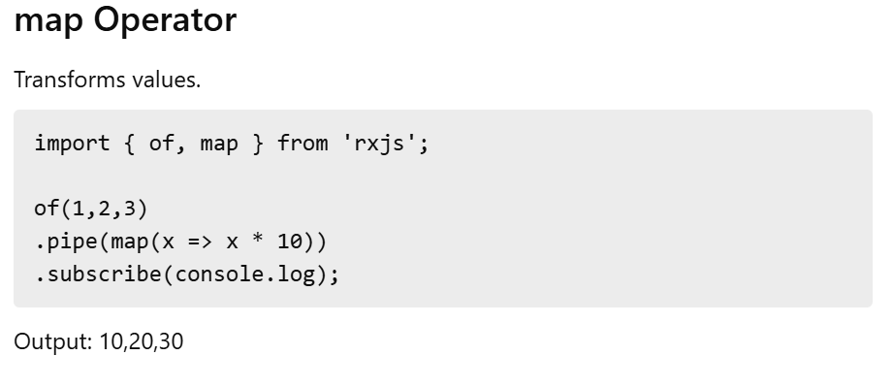

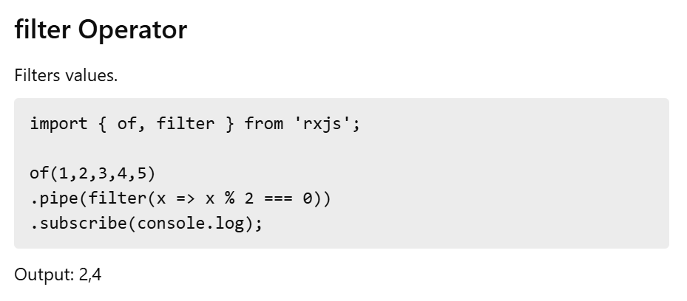

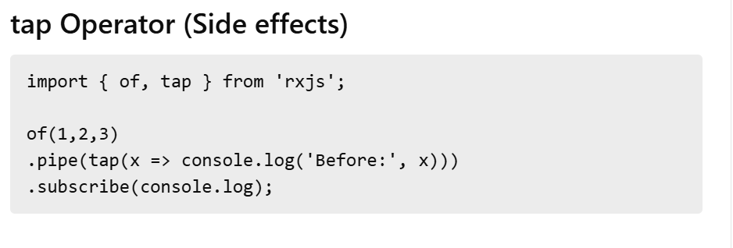

Switch map is a higher order mapping operator ,it maps each value to a new Observable
---cancels the previous observable when a new value arrives
---subscribe only the lates one.(focus on the new value and ignore the old one)
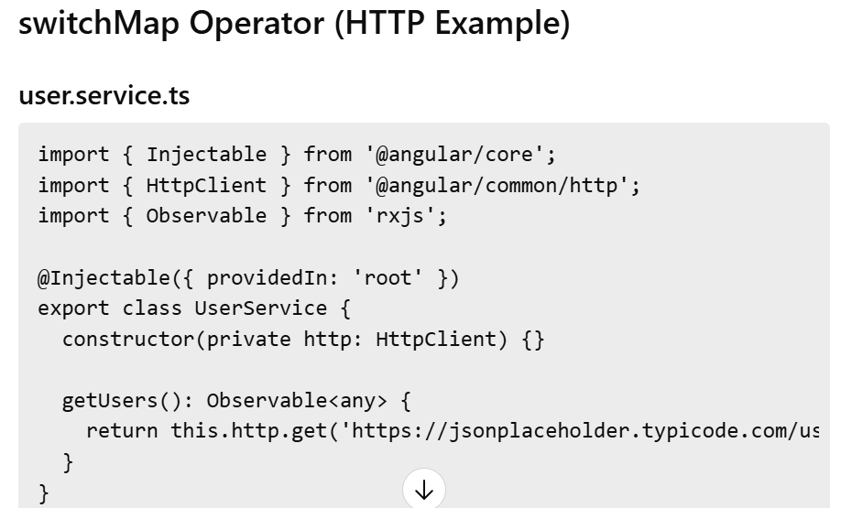

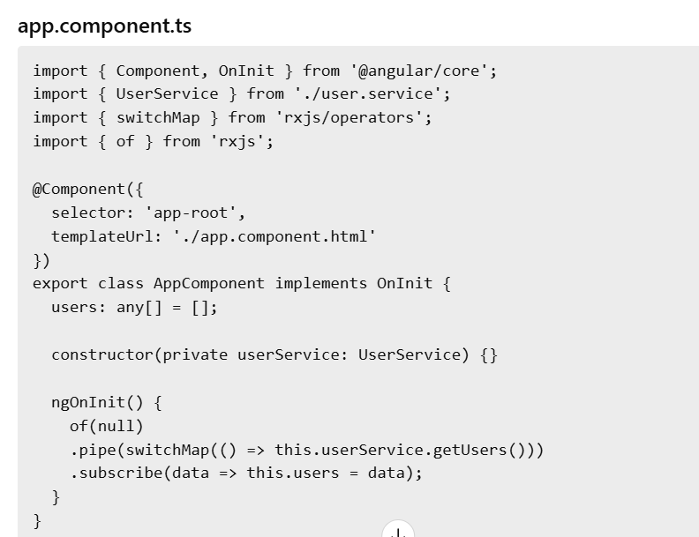

RxJS Subjects
What is a Subject?
A Subject is both:
- Observable
- Observer
It allows multicasting (same data to multiple subscribers).
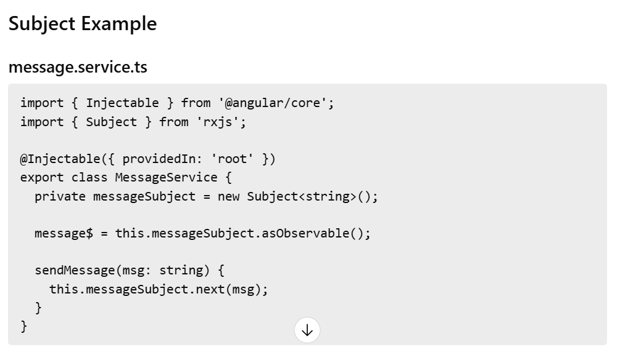

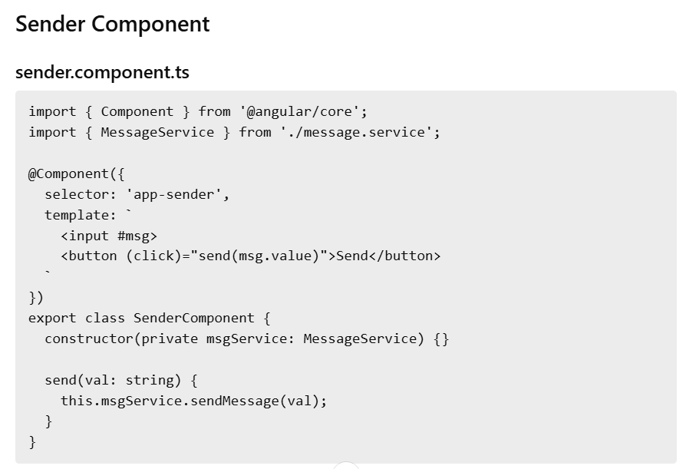

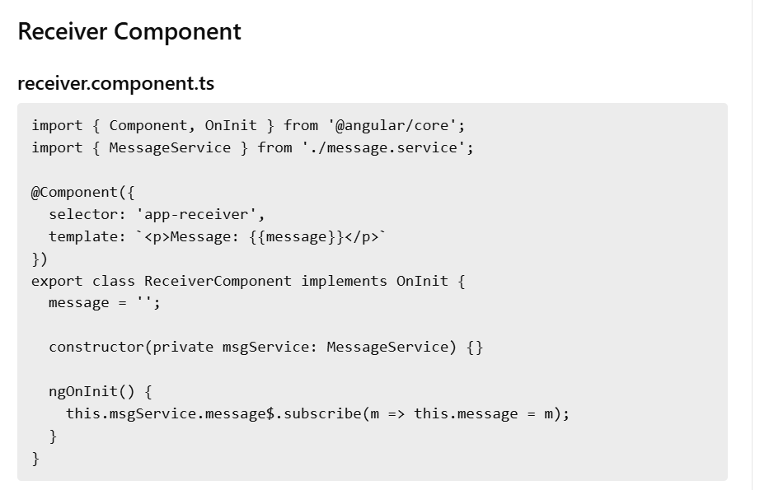

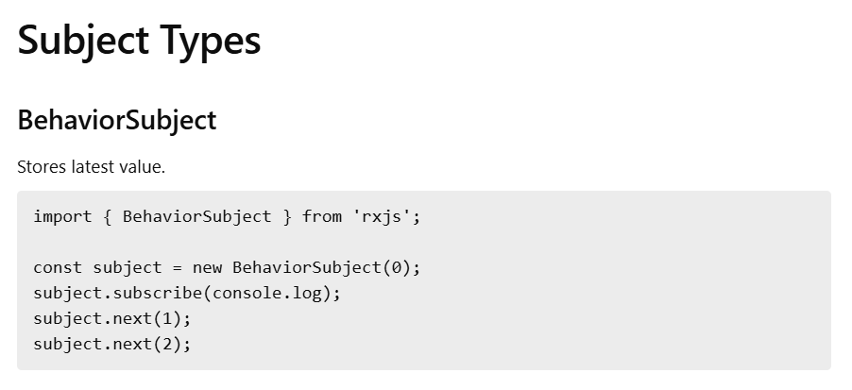

One producer ----one subscriber
One producer ----many subscribers ------

